

**Get In Touch**

Capers in Jars Fron 80g to 5kg

or

Drums of 10 / 40 / 110 / 180 Kg

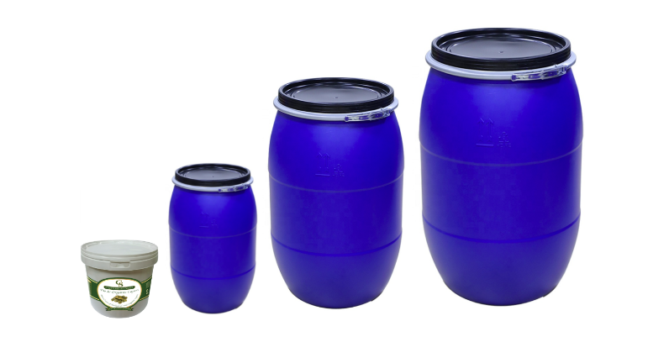

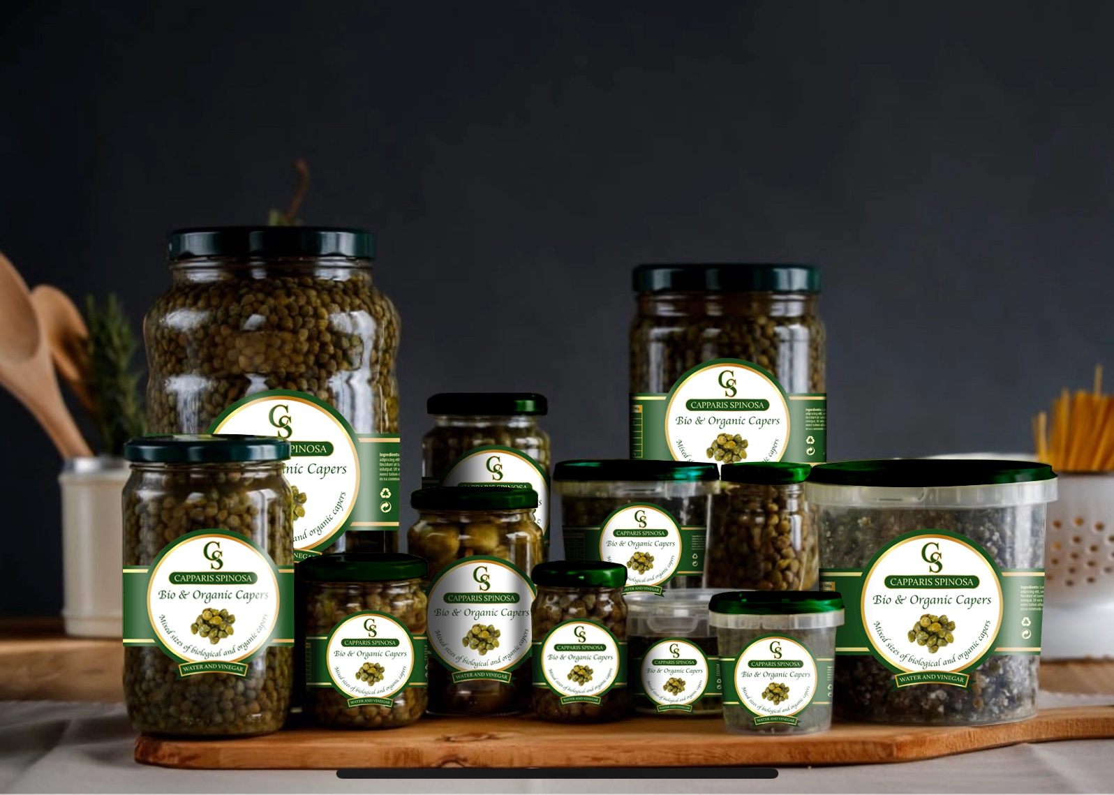

Capers in Vinegar

**Capers Jar with vinegar**

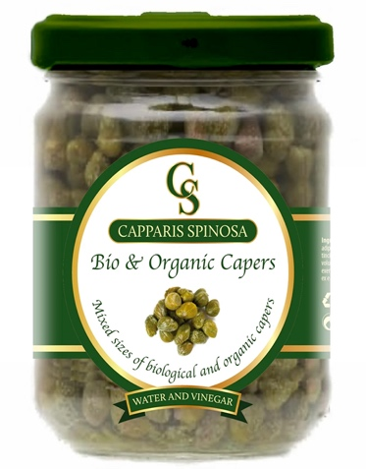 **80g**

Capers with wine vinegar and salt

Caliber 7 to 10mm

Net weight 80g

Drained weight 45g

**Packaging**

Cylindrical jar glass with RTS closing cap Selling Box Unit 30x80g

Pack of 30 jars in lithographed cardboard Box weight 5,300 kg

**Capers Jar with vinegar**

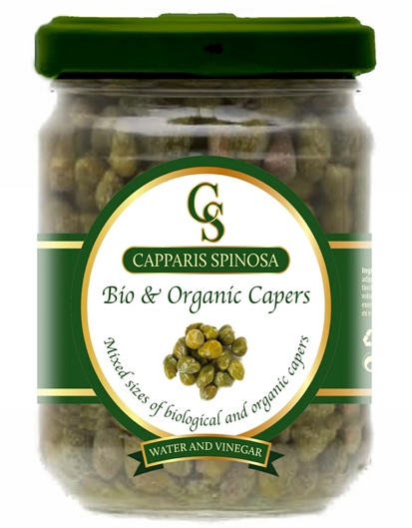 **100g**

Capers with wine vinegar and salt

Caliber 3 to 7mm

Net weight 100g

Drained weight 55g

**Packaging**

Cylindrical jar glass with RTS closing cap Selling Box Unit 24x100g

Pack of 24 jars in lithographed cardboard Box weight 4,680 kg

**Capers Jar with vinegar**

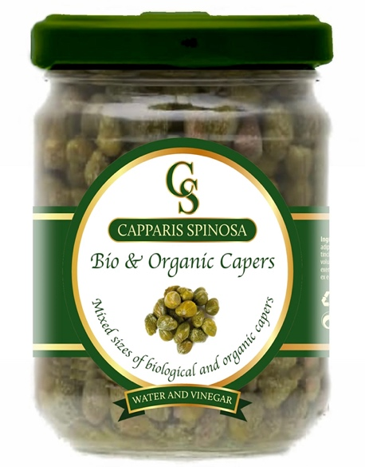 **200g**

Capers with wine vinegar and salt

Caliber 7 to 12mm

Net weight 200g

Drained weight 120g

**Packaging**

Cylindrical jar glass with RTS closing cap Selling Box Unit 12x200g

Pack of 12 jars in lithographed cardboard Box weight 4,240 kg

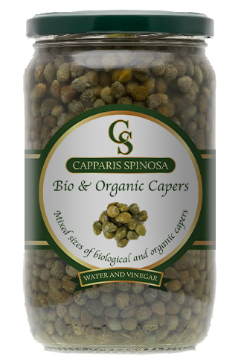 **Capers Jar with vinegar**

**720g**

Capers with wine vinegar and salt

Caliber 7 to 12mm

Net weight 720g

Drained weight 420g

**Packaging**

Cylindrical jar glass with RTS closing cap Selling Box Unit 6x720g

Pack of 6 jars in lithographed cardboard Box weight 6,400 kg

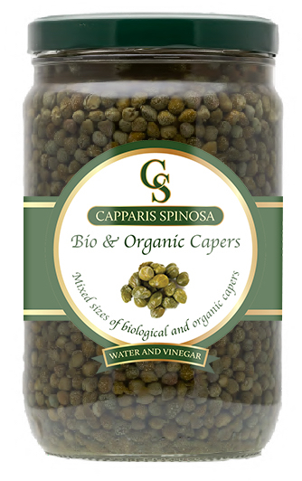

**Capers Jar with vinegar**

**1700g**

Capers with wine vinegar and salt

Caliber 7 to 12mm

Net weight 1700g

Drained weight 1000g

**Packaging**

Cylindrical jar glass with RTS closing cap Selling Box Unit 4x1700g

Pack of 4 jars in lithographed cardboard Box weight 9,900 kg

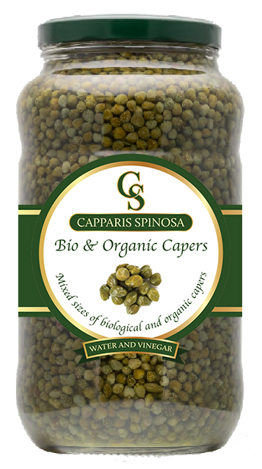

**Capers Jar with vinegar**

**3100g**

Capers with wine vinegar and salt

Caliber 7 to 12mm

Net weight 3100g

Drained weight 2000g

**Packaging**

Cylindrical jar glass with RTS closing cap Selling Box Unit 2x3100g

Pack of 2 jars in lithographed cardboard Box weight 8,600 kg

Caper-Berries in Vinegar



**Caper-Berries with vinegar**

 **370g**

Capers with wine vinegar and salt

Caliber 13/15

Net weight 370g

Drained weight 180g

**Packaging**

Cylindrical jar glass with RTS closing cap Selling Box Unit 12x370g

Pack of 12 jars in lithographed cardboard Box weight 6,700 kg

 **Caper-Berries with vinegar**

**720g**

Capers with wine vinegar and salt

Caliber 13/15

Net weight 720g

Drained weight 350g

**Packaging**

Cylindrical jar glass with RTS closing cap Selling Box Unit 6x720g

Pack of 6 jars in lithographed cardboard Box weight 6,400 kg

 **Caper-Berries with vinegar 1700g**

Capers with wine vinegar and salt

Caliber 13/15

Net weight 1700g

Drained weight 800g

**Packaging**

Cylindrical jar glass with RTS closing cap Selling Box Unit 4x1700g

Pack of 4 jars in lithographed cardboard Box weight 9,900 kg



**Caper-Berries with vinegar**

**3100g**

Capers with wine vinegar and salt

Caliber 13/15

Net weight 3100g

Drained weight 1800g

**Packaging**

Cylindrical jar glass with RTS closing cap Selling Box Unit 2x3100g

Pack of 2 jars in lithographed cardboard Box weight 8,600 kg

Sea Salt Capers

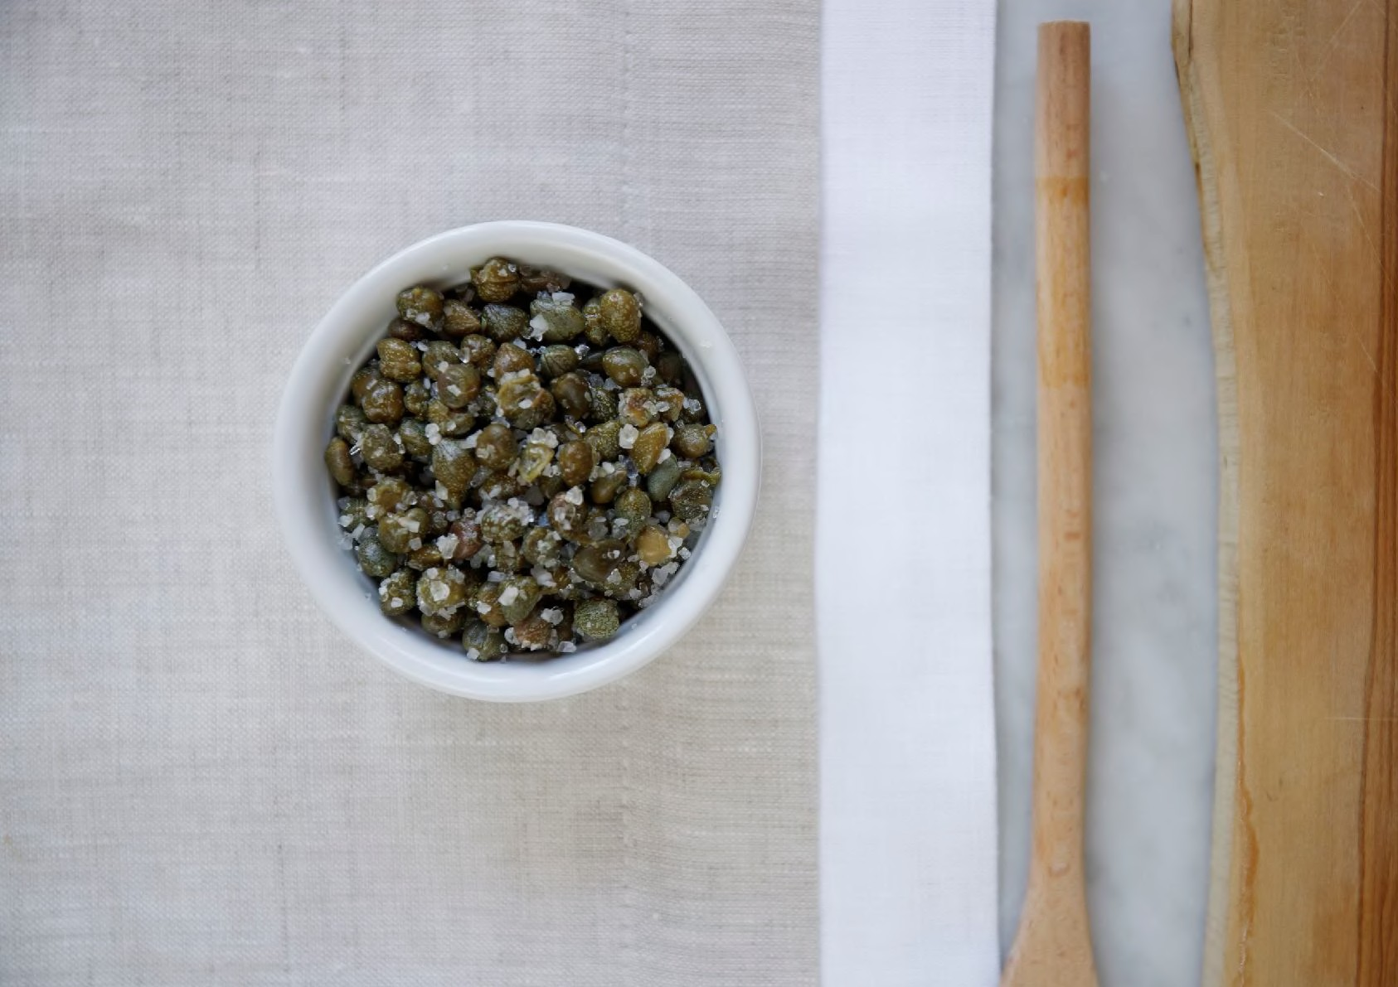

**Capers Jar with sea salt**

**70g**

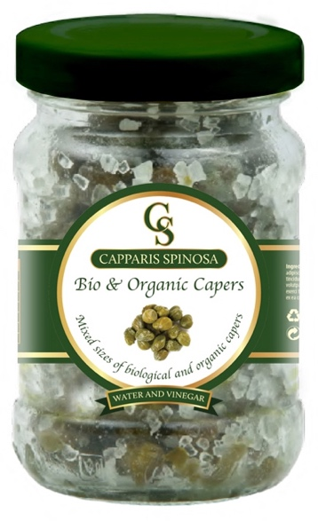 Capers with sea salt

Caliber 7 to 10mm

Net weight 70g

**Packaging**

Cylindrical jar glass with RTS closing capsule Selling Box Unit 24x70g

Pack of 24 jars in lithographed cardboard Box weight 4,680 kg

**Capers Jar with sea salt**

**100g**

Capers with sea salt

 Caliber 7 to 12mm

Net weight 100g

**Packaging** Cylindrical Plastic jar with tear-off seal Selling Box Unit 24x100g

Pack of 24 jars in lithographed cardboard Box weight 2,800 kg

**Capers Jar with sea salt**

 **250g**

Capers with sea salt

Caliber 7 to 12mm

Net weight 250g

**Packaging** Cylindrical Plastic jar with tear-off seal Selling Box Unit 12x250g

Pack of 12 jars in lithographed cardboard Box weight 3,230 kg

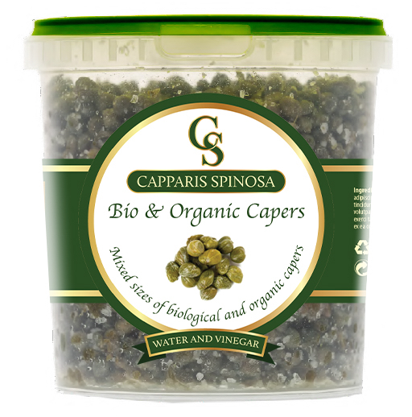

**Capers Jar with sea salt**

**1000g**

Capers with sea salt

Caliber 3 to 12mm

Net weight 1000g

**Packaging**

Cylindrical Plastic jar with tear-off seal Selling Box Unit 6x1000g

Pack of 6 jars in lithographed cardboard Box weight 3,230 kg

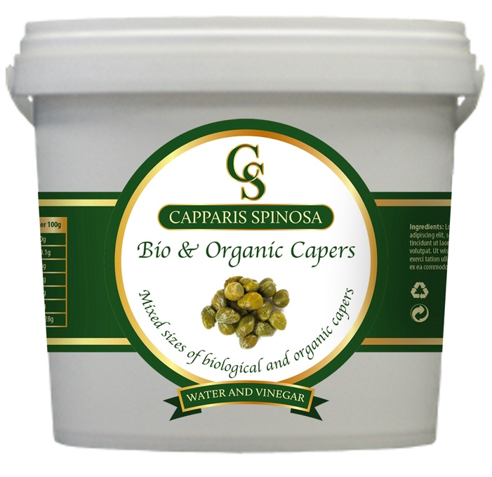 **Capers Jar with sea salt**

**5000g**

Capers with sea salt

Caliber 3 to 12mm

Net weight 5000g

**Packaging**

Cylindrical Plastic jar with tear-off seal Selling Box Unit 1x5000g

1 Bucket

Bucket weight 5,230 kg



